AKSHAT SRIVASTAVA
202401100200032
CSE-A

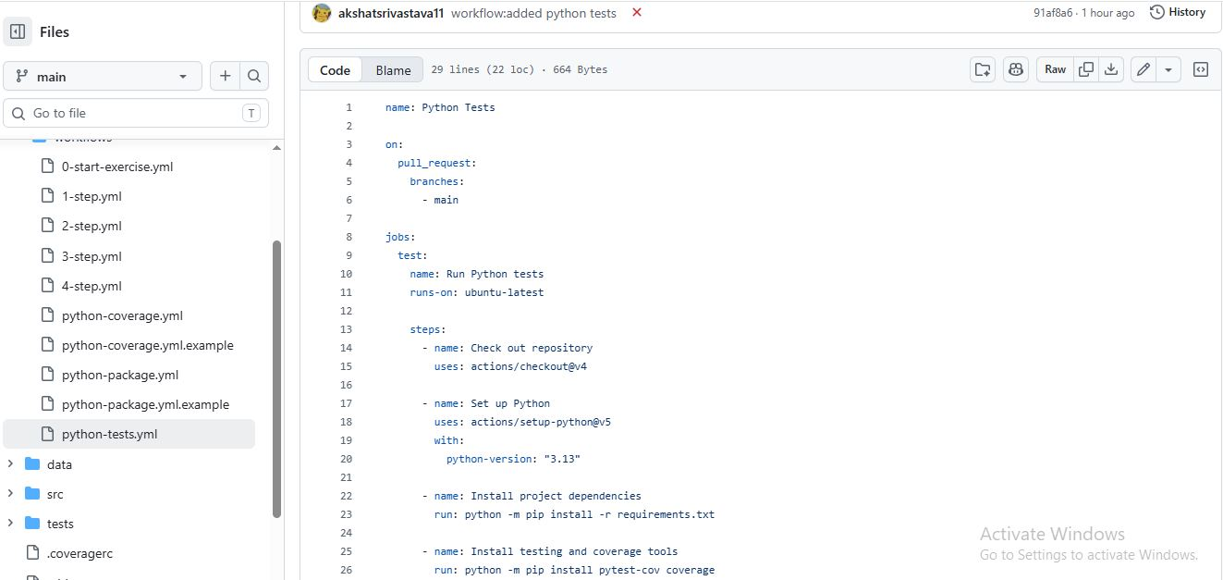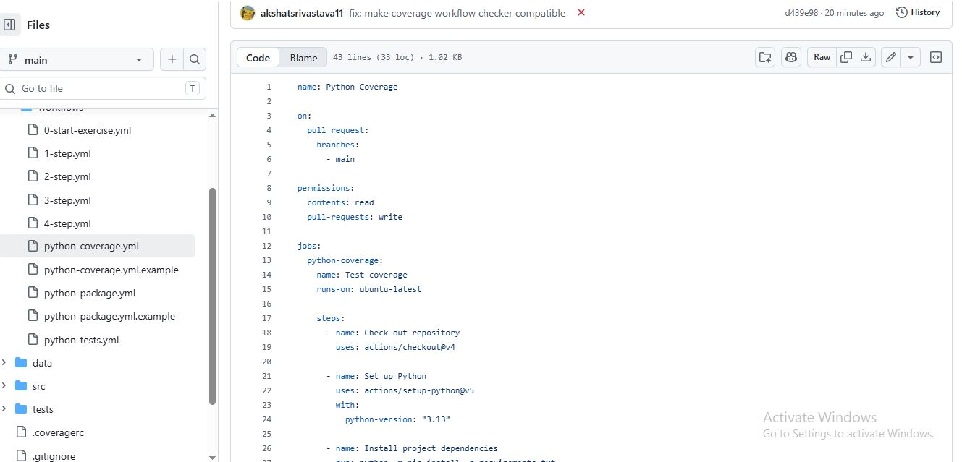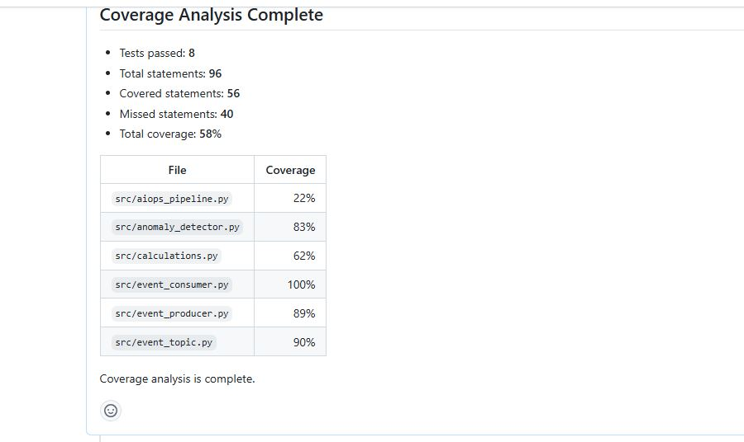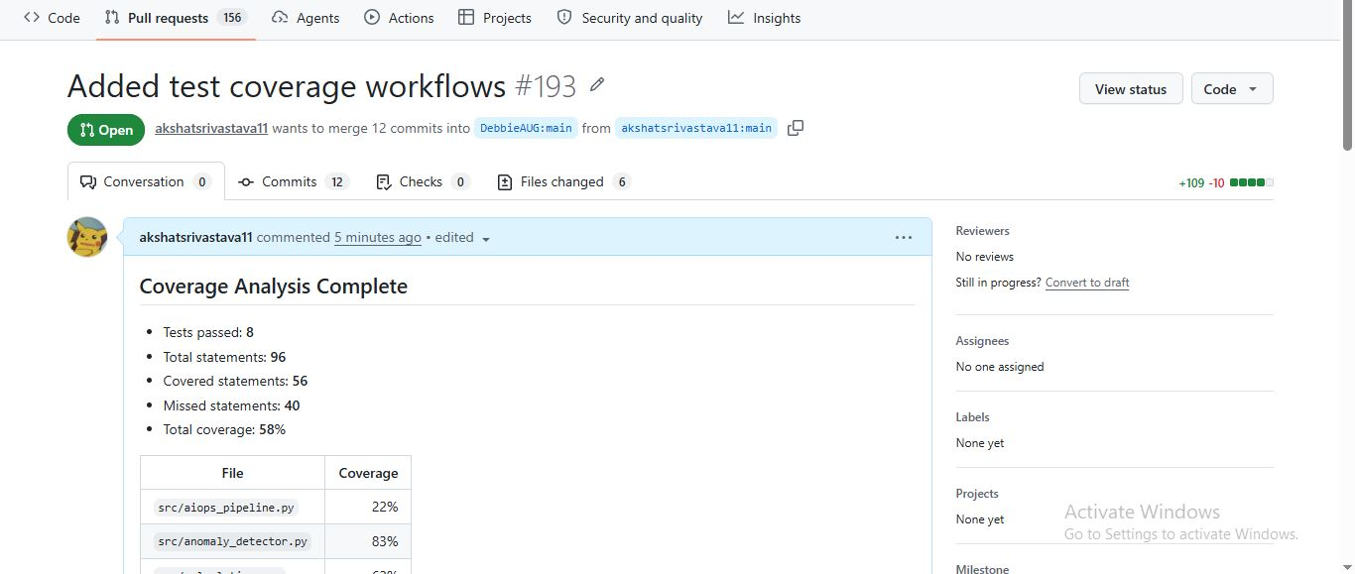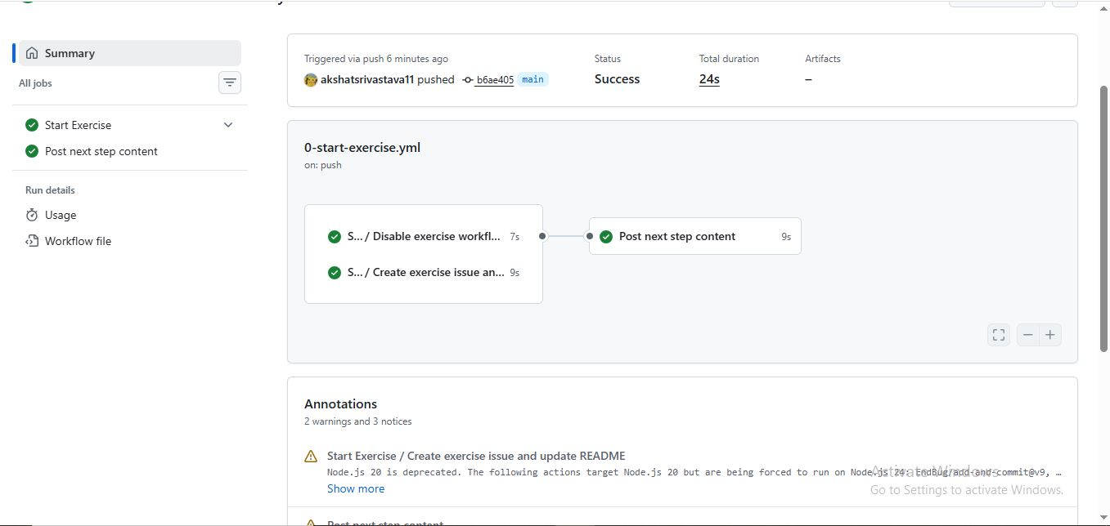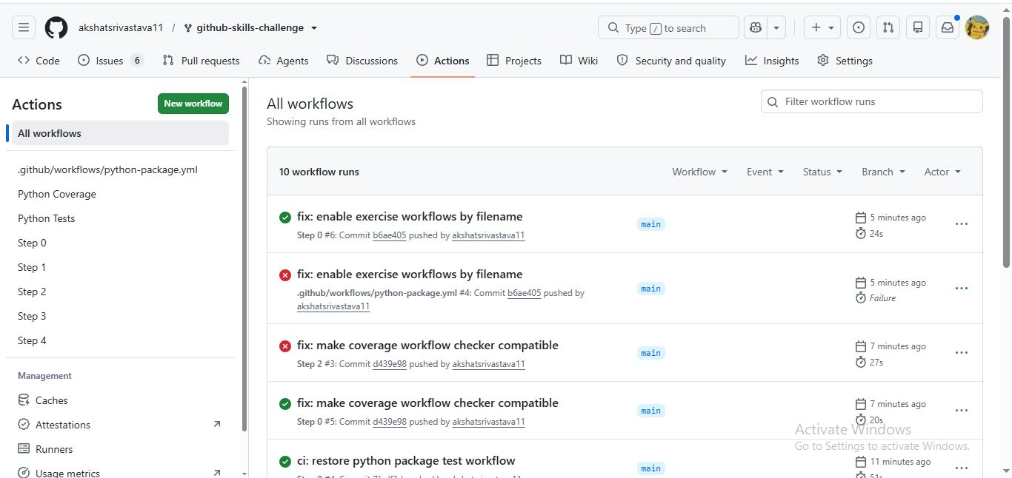

Github pr URL: https://github.com/DebbieAUG/github-skills-challenge/pull/193
Github repo url: https://github.com/DebbieAsUG/github-skills-challenge/pull/193

